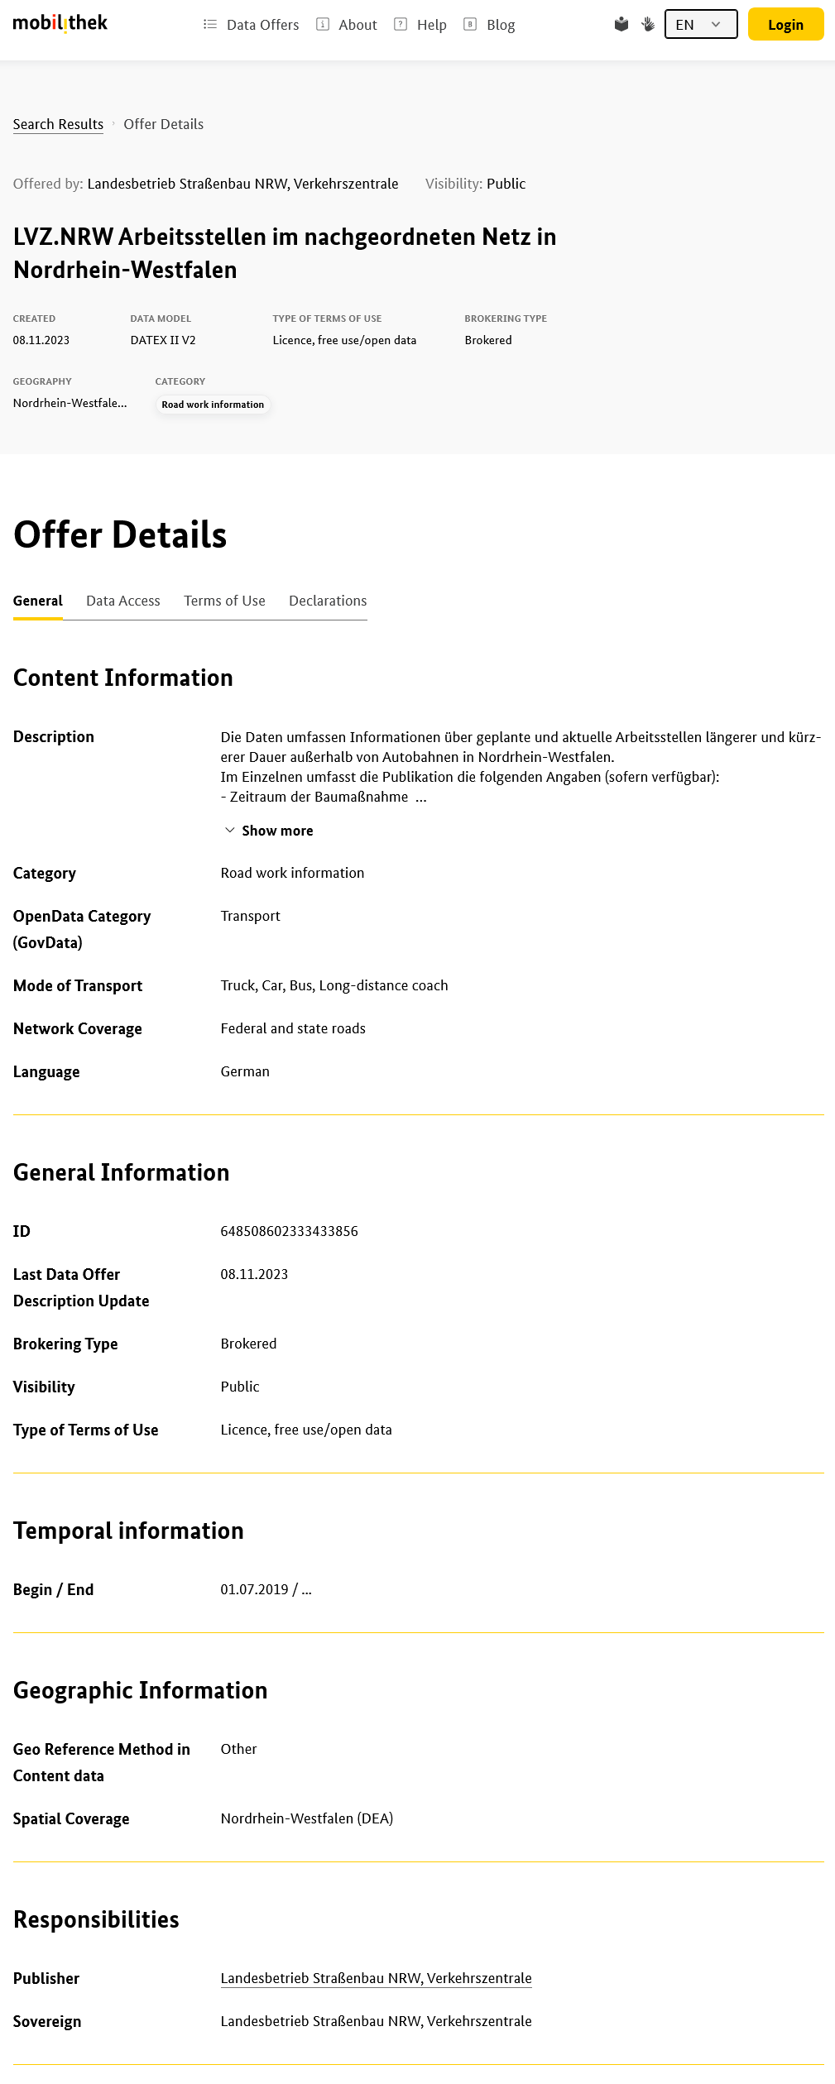

*mobilitydcatap:transportMode*

*dcat:theme*

*dct:spatial*

*dct:RightsStatement/dct:type*

*mobilitydcatap:mobilityTheme*

*dct:rightsHolder*

*dct:publisher*

*mobilitydcatap:georeferencingMethod*

*dct:PeriodOfTime/dcat:startDate*

*dct:spatial*

*mobilitydcatap:mobilityDataStandard*

*dct:issued*

*dct:identifier*

*dct:modified*

*dct:language*

*mobilitydcatap:networkCoverage*

*mobilitydcatap:mobilityTheme*

*dct:title*

*dct:description*